AWS Lambda:

**Lambda Layers:**

1. **Create folder named python and run pip install requests -t python**
2. **zip -r lambda_layer.zip python**
3. **upload directly or to s3**

* Here are the default names that are used.
  + Program Name: **lambda_function**
  + Function Name: **lambda_handler**
* 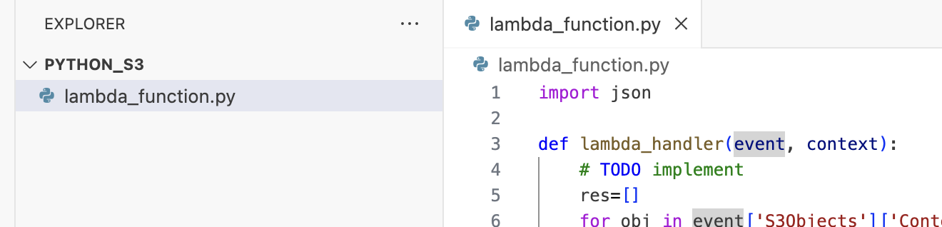
* 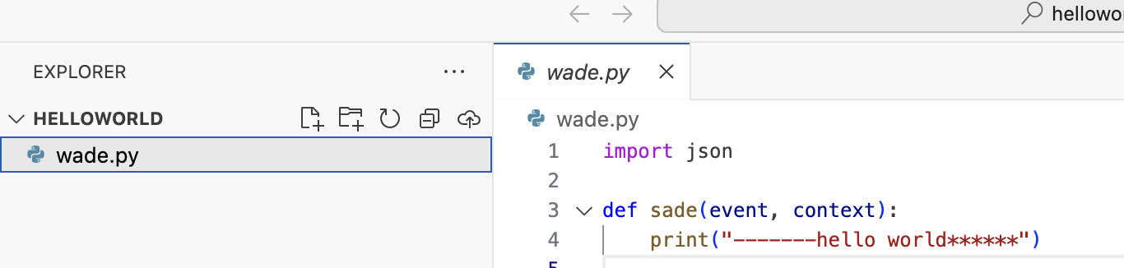
* We can upload either from s3 or zip file
* To upload 3rd party libraries we can run
* pip install requests -t .
* and then zip whole working directory: zip -r test.zip .
* Configuration has all the info, you can check there:
* 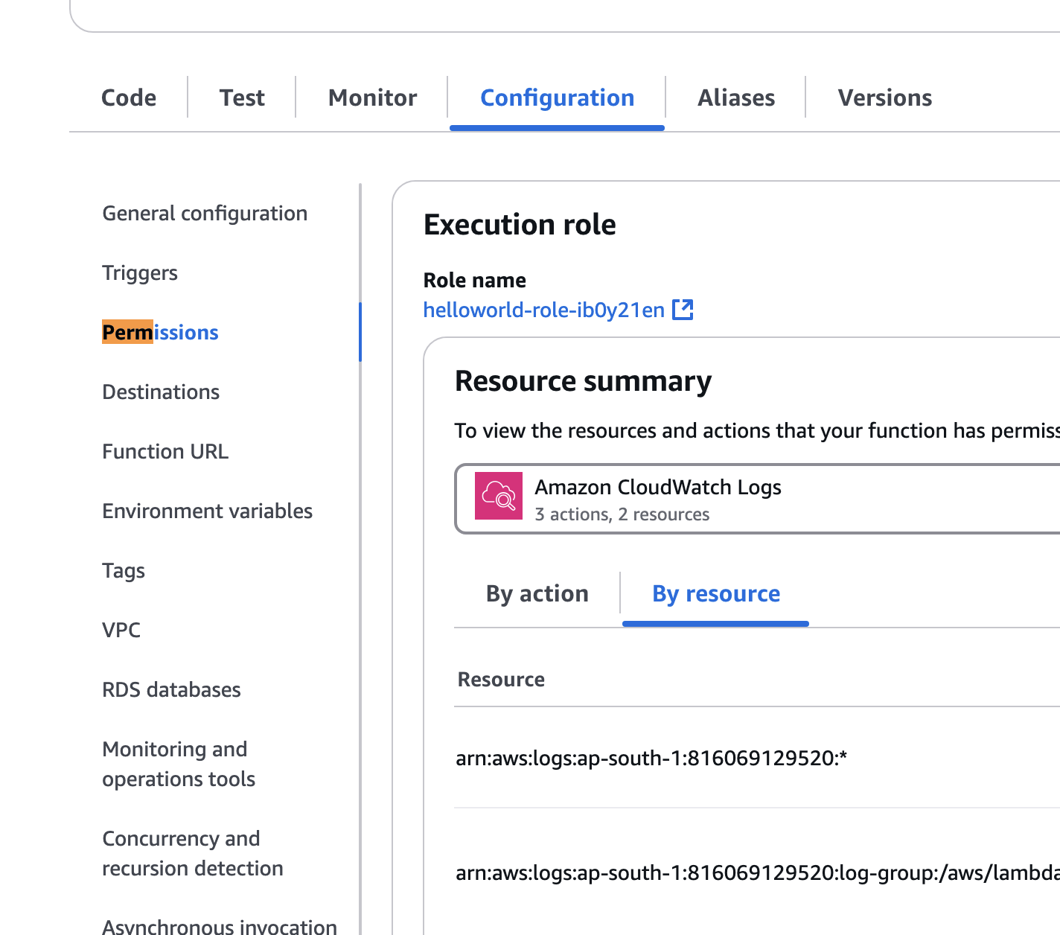
* We can use AWS event bridge to schedule lambda functions
* We can also attach trigger for execution and SNS for notification after lambda function execution
* 